EXPERIMENT : 3

NAME : KRISHNAKUMAR.R ROLL NO : 240701275

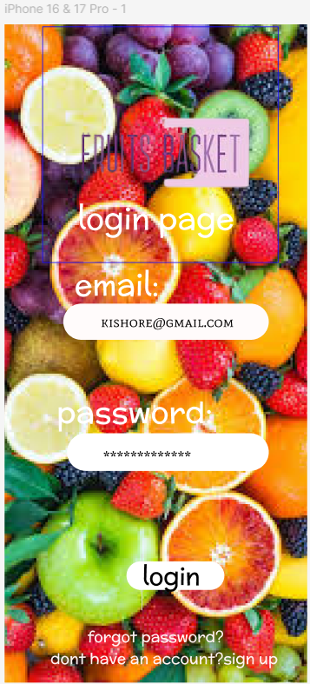

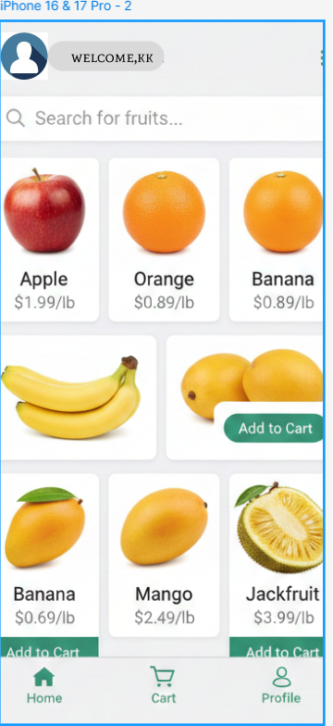

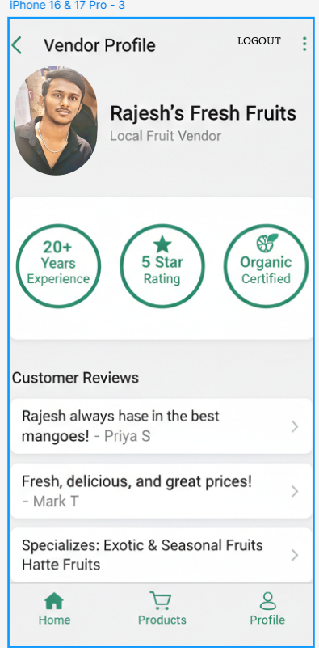

Experiment: Fruit Basket Mobile Application Interface
Aim
To design and develop a Fruit Basket mobile application interface that allows users to login, browse fruits, view vendor details, and add products to the cart easily.

Objective
- To create a simple and user-friendly fruit shopping application.
- To allow customers to search, view, and purchase fruits online.
- To display vendor information and customer reviews.
- To provide an easy add-to-cart shopping feature.

Components / Tools Used
- Mobile UI Design
- Smartphone / Emulator
- Android Application Interface
- Internet connectivity

Description of Screens
1. Login Page
The login page is the first interface of the application.
Features:
- Background image showing different fruits.
- Email input field for entering user email.
- Password input field for secure login.
- Login button to access the application.
- “Forgot Password” option for password recovery.
- “Sign Up” option for new users to create an account.
Purpose:
This page authenticates users before accessing the application.

2. Home Page (Fruit List)
After login, the user enters the Home Page where fruits are displayed.
Features:
- Welcome message for the user.
- Search bar to search for fruits.
- Fruit list displayed with images, names, and prices.
- Example fruits:
  - Apple – $1.99/lb
  - Orange – $0.89/lb
  - Banana – $0.89/lb
  - Mango – $2.49/lb
  - Jackfruit – $3.99/lb
- Add to Cart button for purchasing items.
- Bottom navigation bar with Home, Cart, and Profile options.
Purpose:
Allows users to browse fruits and add items to their cart.

3. Vendor Profile Page
This page shows the fruit vendor details.
Features:
- Vendor name: Rajesh’s Fresh Fruits
- Vendor profile image
- Vendor description: Local fruit vendor
- Vendor highlights:
  - 20+ Years Experience
  - 5 Star Rating
  - Organic Certified
- Customer reviews from buyers.
- Specialization in Exotic and Seasonal Fruits.
Purpose:
Provides trust and credibility about the fruit seller.

Procedure
- Open the Fruit Basket application.
- Enter the email and password on the login page.
- Click the Login button.
- After login, view the Home Page showing fruit products.
- Search for fruits using the search bar.
- Select a fruit and click Add to Cart.
- View vendor details in the Profile page.

Result
The Fruit Basket application interface was successfully designed, allowing users to login, browse fruits, view vendor details, and add fruits to the cart efficiently.

LINK:
https://www.figma.com/design/x5xaGz9ry60O9ijB0AK3g8/Untitled?node-id=0-1&t=JkZdpEoGxsFHo3XY-1

